**INDUSTRY – SPECIFIC INTELLIGENT FIRE MANAGEMENT SYSTEM USE DASHBOARD NODES FOR CREATING UI**

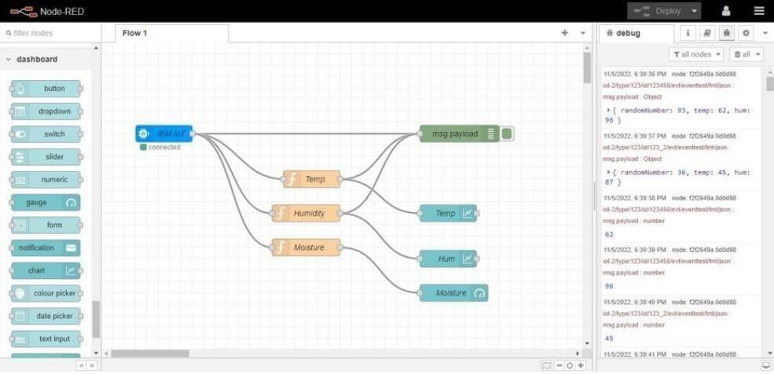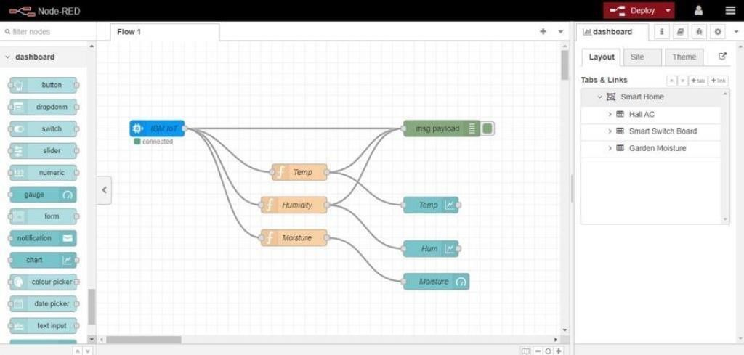

**(WEB APP)**

|  |  |
| --- | --- |
| Team ID | PNT2022TMID31844 |
| Project Name | Industry Specific Intelligent Fire Management System |

